
Politecnico di Milano – V Facoltà di Ingegneria

075274 e 070644 - Sistemi distribuiti (con laboratorio)
Prof. G. Cugola

Appello del 15 Settembre 2010
Rules:
- You are not allowed to use books, notes, or other material.
- You can answer in Italian or English.
- Total time for the test: 2 hours.

- Implement in Java a PriorityQueue. The size of the queue is determined at creation time (through the constructor). A single method void enqueue(int data) exist to enqueue data. Callers of such method are suspended if the queue is full. As for dequeuing, two methods exist: int dequeueLowP() and int dequeueHighP(). The callers of the latter, if any, have higher priority in accessing new data (they are waked up before the others when a new item is added to an empty queue).

- Describe the mobile code architectural style, highlighting the different form of code mobility that exist.

- Describe how to use vector clocks to build a causally ordered multicast service.

- Consider the system in figure, which is running a distributed snapshot. Suppose that every process works by adding the value held by the received messages to its internal state S. Process A started the snapshot sending the token to processes C and E (already processed).

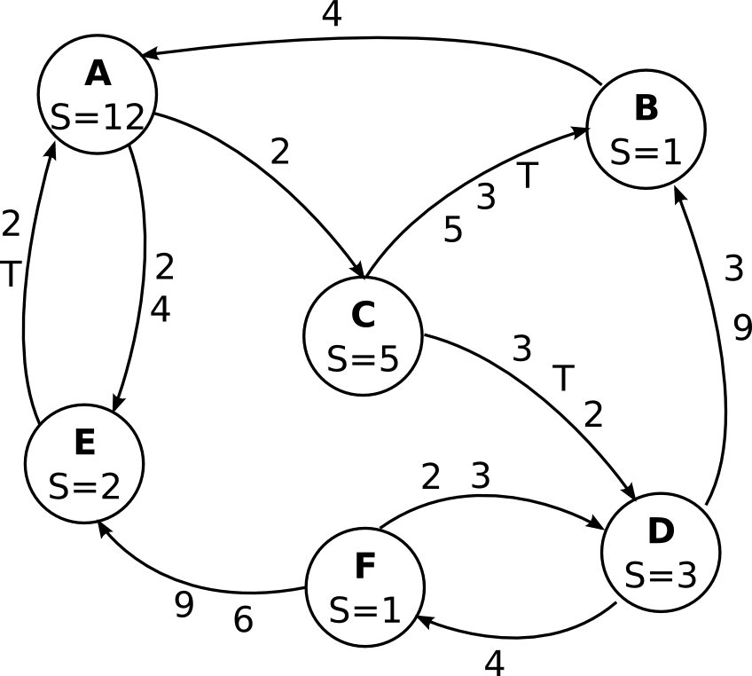

Assuming that no other operations occur apart those required to end the snapshot and that the output channels of C are much faster than the other channels, show the state captured by every node at the end of the snapshot (local state and messages recorded for each link).

- Describe the floodset algorithm: its goal, the assumptions it relies on, the algorithm, the proof of correctness.

- Consider the following schedule:
P0: W(x) 1 R (x) 2 W(x) 3
P1: R (x) 1 W(x) 2 R(x) 3
P2: R (x) K R (x) ?
Complete the table below, by showing, for each value of K, the set of values (1, 2, 3) that process P2 can read during its second operation when adopting a FIFO or a sequential consistency model. Motivate your answers.
Value of K | Consistency model | Set of allowed values
1 | FIFO
1 | Sequential
2 | FIFO
2 | Sequential
3 | FIFO
3 | Sequential

- Describe (briefly) and compare the following mechanisms used to set up secure channels:
- Authentication using shared secret key (challenge response)
- Authentication using public key
- Authentication using a key distribution center
Which assumptions are required by these protocols? Which are their limitations?

